Supported by the United Way of Leeds and Grenville
2022 Annual Report

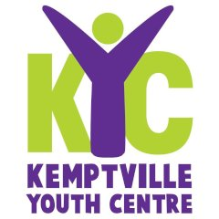
Rolston Hall,5 Oxford St. West,
Box 1124
Kemptville, ON K0G 1J0
T. 613-258-5212
VISIT: www.kyc.team
Charitable Organization 88830029ORRR0001v

MESSAGE FROM OUR PRESIDENT
For over 29 years KYC has been a safe, friendly haven for youth to drop in after school and in the evenings. KYC has an ever changing, amazing team of staff, board members and volunteers who bring diversity and enthusiasm to our Centre coupled with a great group of youth that participate regularly in Centre activities.

In 2022 we regrettably said farewell to Barb Tobin and Micaela Comerford but welcomed Roxanne and Karley. Both have settled in well and brought new ideas and enthusiasm to their roles.

We completed the installation of a basketball
facility at the rear of the building using our own
Funds and a $4,000 grant from the North
Grenville Municipality. It doubles as a street
hockey rink in the winter!

In 2022 we had good fund raising by way of a successful Book Fair and the Golf Tournament.

With the aid of a Trillium Foundation of Ontario Grant we completed a review of KYC operations which resulted in plans for 2023
to enhance social media, make KYC more of a “hub” for youth services and pay more attention to youth mental health programs.

Karley Hoyland joined us in December 2022. Earlier in the year we said goodbye to Micaela Comerford who with Barb Tobin had done so much for KYC. Karley has a DCS/DCE in Social Service Work from St Lawrence College and has previously worked as a community support worker.

Major support from United Way of Leeds and Grenville was as always vital to our continues operation

Bruce Wehlau, President, 2022

2022 Board of Directors

Bruce Wehlau, President
Missy Henshall, Vice-President
Brian Arleth, Treasurer
Beth Searle Secretary
Jason Blakey
Shannon Lever
Claude Smith
Nancy Miller-McKenzie

Manager & Program Coordinator
Roxanne Trumble Elliston is our Operations Manager following the retirement of Barb Tobin. Roxanne joined KYC in June 2022. Roxanne brings 35 years of experience working in child and mental health services and a passion for youth empowerment, youth advocacy and youth engagement.

Roxanne Trumble-Elliston:
The year 2022 was a year of change for KYC. We experienced a 100% turnover in our staff team. KYC said good bye to Barb Tobin and Micaela Comerford and welcomed Karley Hoyland as the Program Coordinator and myself as the Operations Manager. Thanks to Julia Henderson, our Algonquin College placement student, who supported KYC between program coordinators.
KYC was fortunate to receive funding from the Canada Summer Works Program that allowed us to hire an assistant program coordinator over the summer months to support enhanced programming and community outings for youth. As well we were grateful to the North Grenville Municipality Recreation Department for their generosity in sharing time of their summer interns to focus on enhancing our recreational programming over the summer months.
This year KYC participated in the Old Town Kemptville Halloween celebration of “Kreepy Kemptville”. Our youth enthusiastically embraced the opportunity to turn the centres basement into a Witches House. Our youth volunteers toured children and families through our spooky witches house and gave out treats to approximately 275 children. This was so much fun!
Through a generous Ontario Foundation Trillium grant, KYC was able to complete an assessment and review of programs and services – with the input of youth, stakeholders, community, Board and staff team. The outcome of this was a clear intention to re-brand KYC as a Youth Hub and to expand the centres mental health initiatives, enhance our social media, strengthen youth programming and our collaborative community partnerships.
The purpose of KYC remains dedicated to providing youth a safe and inclusive environment in which to be their “best self”. We remain most grateful to the many volunteers who support KYC with the gift of their time and to the generous donations of our community members and businesses.

Positive minds, Positive Vibes, Positive Life!

Positive Minds, Positive Vibes, Positive Life!

Did you know …
KYC provides an E-Waste recycling program to our community.
In 2022 we were able to divert over 50,000 kilos. of material from our local landfill site.
Our collection of bottles and cans from the North Grenville Landfill and surrendered to the Beer Store yielded $2,000
Great job North Grenville and thanks for supporting KYC and the environment!

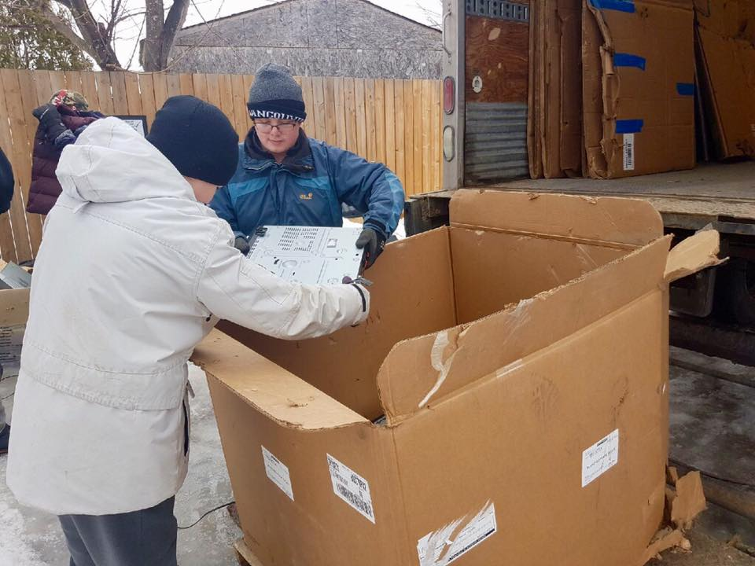

Our Report Card - How are we doing?

Our 2022 priorities again were:

- Membership - KYC will maintain youth participation /attendance

Numbers were down at the beginning of the year but have recovered towards the end of the year. Our monthly stats continued to grow and there were several new youth joining the fun! On average we see now see 15 regulars a day- but numbers vary depending on activities and time of year.

- Community - KYC will increase the number of community partnerships by one per quarter.

KYC: We are forging partnerships with Big Brothers Big Sisters and continuing with Connect Youth

Programming –Programs are constantly reviewed and depend upon youth needs and wants and availability of program mentors. required.
We continue social media use.

- Administration – A difficult year with the staff turnover we initially experienced in 2022 but KYC has returned to normal!
- The process of renewing of KYC web page was completed.

- Building – The KYC owned building continues to be major asset.

Finances and Fundraising – We are constantly looking for more ways to be self-sustainable, be it through long-term pledges, identification and approval for new grants, program cost recovery, and/or increased fundraising.

In 2022 we completed work on installing a basketball facility at the rear of the building. It is about a third the size of a full court with one hoop.
The surface was completed with a grant from the Municipality of Leeds & Grenville towards the cost and the final installation of hoops will be made in spring 2023. The surface made a great skating rink in the winter!

.

FUNDING & SUSTAINABILITY

KYC cannot function without ongoing funding from such organizations such as The United Way, Ross McNeil Foundation, Canadian Tire Jumpstart, Nutrition for Kids (N4K), House of Lazarus just to mention a few.

At the same time, we rely on our fundraising efforts which, in 2022 included:

- KYC Golf Tournament at Rideau Glenn
- Annual Book Fair at the
Ferguson Forest Centre
- Bottle Drive from the NG Municipal Landfill to the Beer Store
- In collaboration with the NG Municipality, the E-Waste collection

KYC also receives numerous donations from all corners of the community.

KYC uses any surplus in fundraising and grants to provide both a 6-month Operations Reserve and a Capital Reserve to ensure that there are funds available for emergencies.

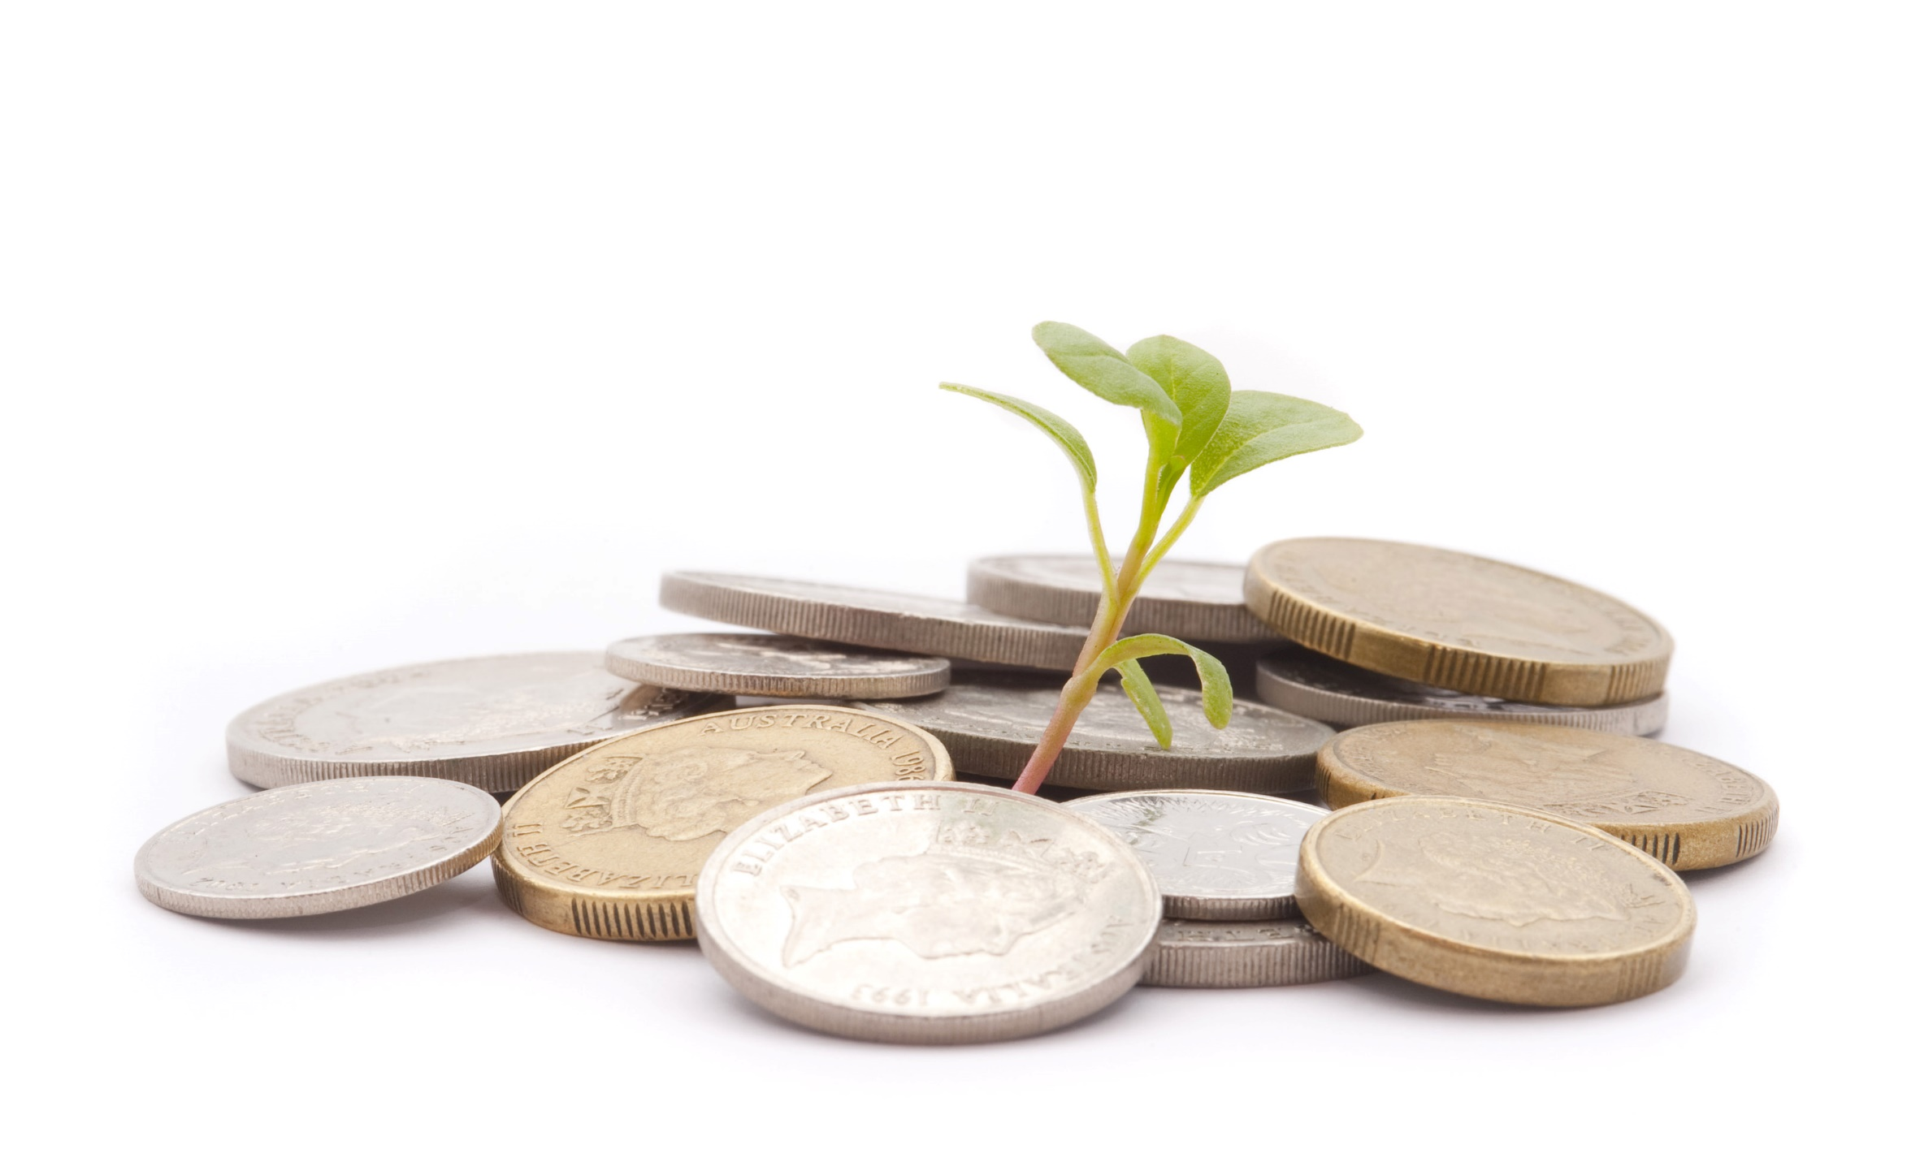

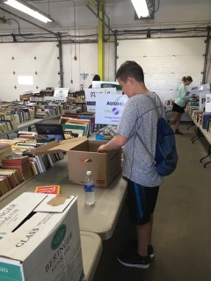
Books, books and more books!
Youth volunteered during sorting, set up, sale and cleanup.
A very successful fundraiser!

2022 Golf Tournament
KYCs’ 4some had a great time!
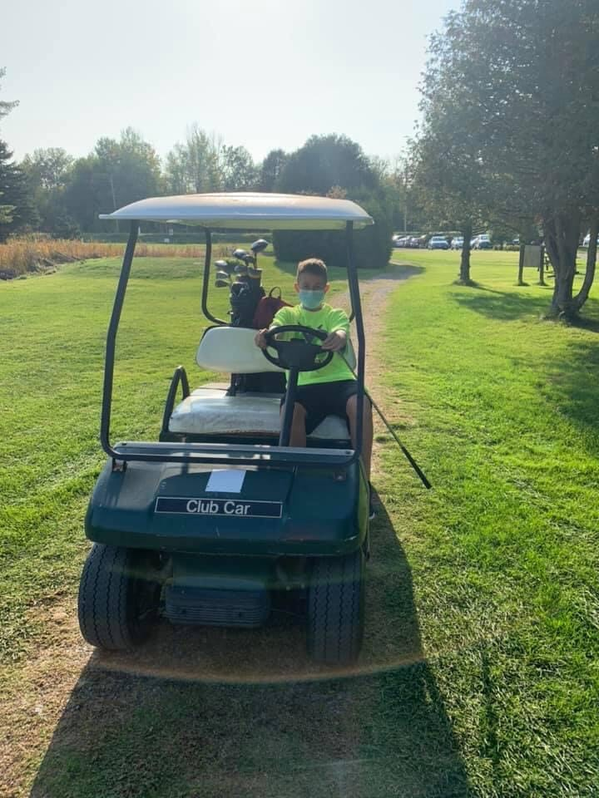

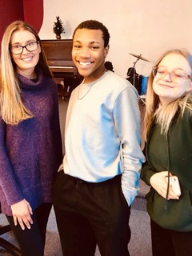

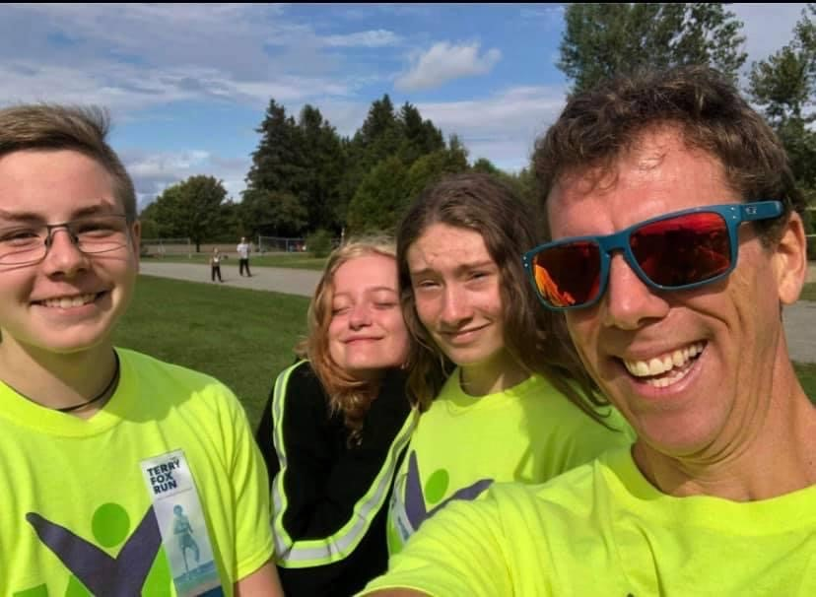
In 2022 KYC offered local youth …
Daily After School Drop-In & Homework Help offered Every Day!
Daily Fun Programs include:
Bake/Cooking Events – Sports Activities – Movie & Arts Activities
Games: Pool – Ping Pong -Board & Computer Games - weekly “Dungeons & Dragons”

+ lots of different events, activities and field trips!

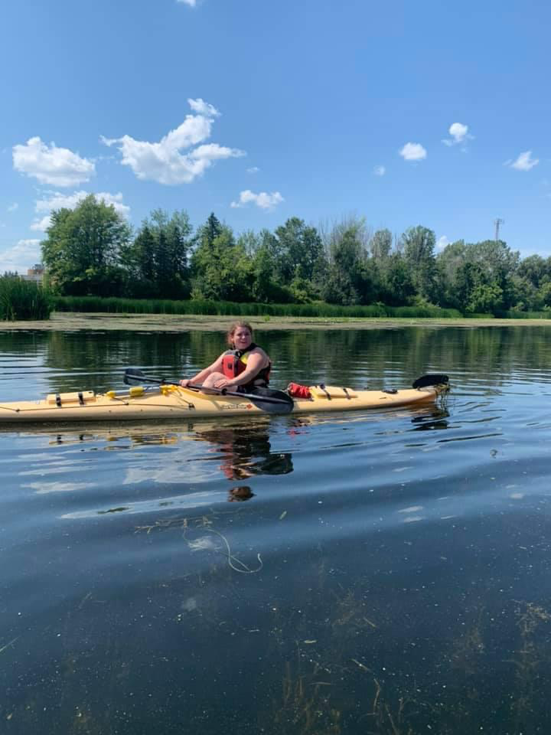

We increasingly step outdoors to be healthy and active!!
Forever health conscious - our Sports are a hit!
.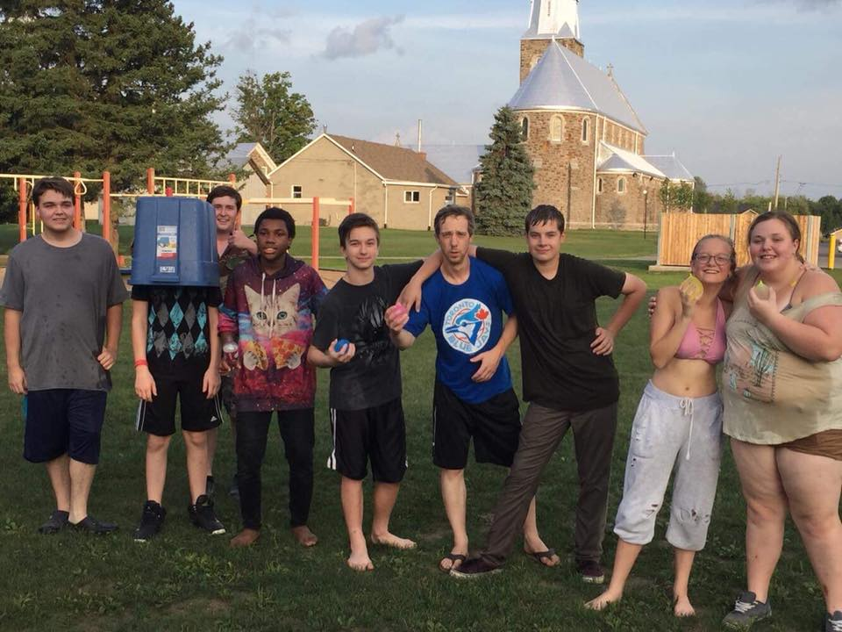

KYC is fortunate to have the support of Canadian Tire Jumpstart and our regular Volunteers as key element of our Sports Programming.

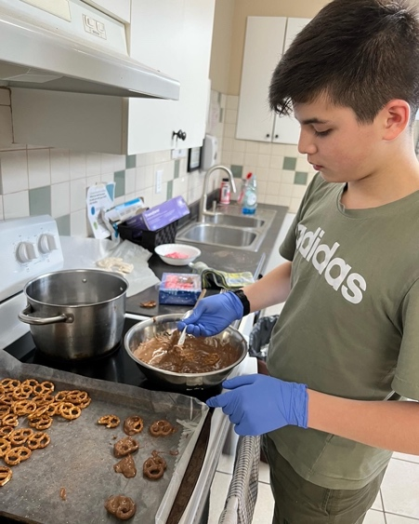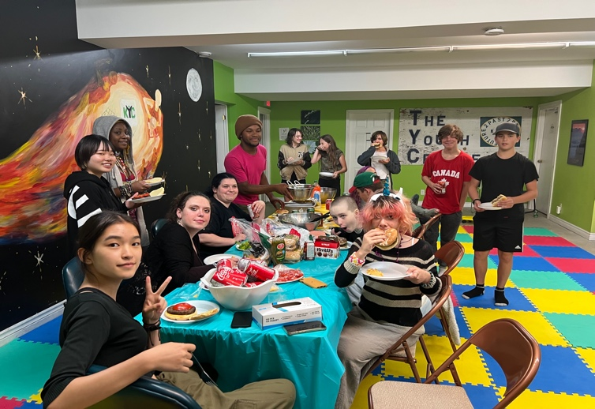
Healthy Cooking and Baking

Jumpstart also makes excursions throughout the region a possibility for everyone!

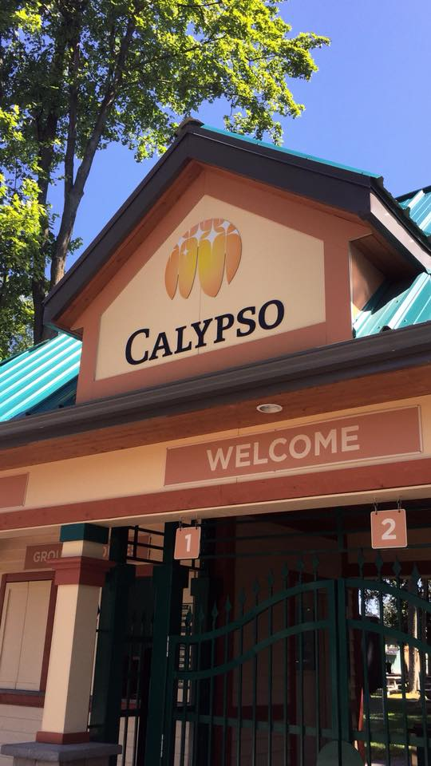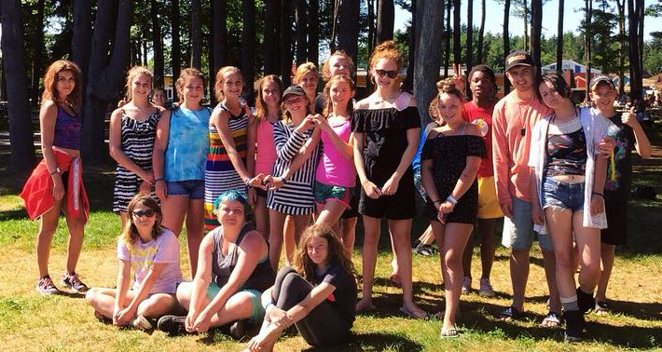
This Favourite Summer Excursion
Would not be possible without our enthusiastic volunteers!
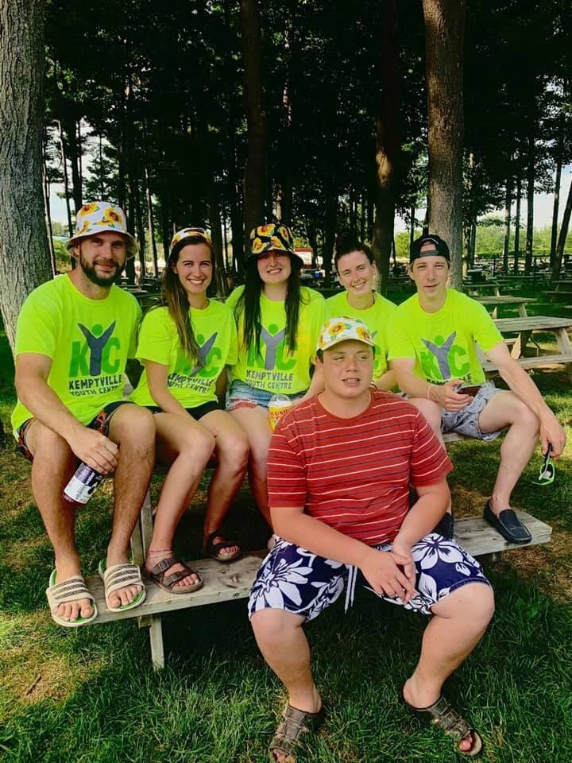

FINANCIAL OVERVIEW

The Kemptville Youth Centre has a qualified volunteer accountant managing its books which are audited annually. Monthly financial reporting to the Board ensures that KYC does not operate in a deficit and maintains its contingency reserves.

2022 saw a return to more normal financial activity as fundraising and grants returned to normal. KYC was able to offer its programs for the year without serious interruption. The basketball court was completed with a grant of $4,000 form the Municipality of North Grenville and we continued to receive support from the United Way of Leeds & Grenville without whom we would be seriously disadvantaged.

In 2022 we received a grant of $20,000 from the Trillium Foundation of Ontario to study how KYC could bolster its resilience post Covid and several recommendations have been made which are receiving consideration and implementation where possible.

KYC continues its practice of maintaining a cash reserve equivalent 6 months of operating costs and a capital reserve of $30,000 in respect of our building.

Brian Arleth
Treasurer

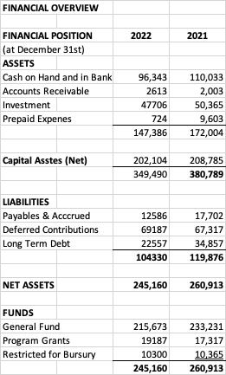
NOTE: Financial Statements have been audited by Walker & Associates

